SIMATS ENGINEERING
ASSESSMENT TOOL 1 – High (Coding Challenge)
COURSE CODE: CSA09 COURSE NAME: Programming in Java
COURSE OUTCOME COVERED
CO1: Apply object-oriented programming principles such as classes, objects, encapsulation, data hiding, inheritance, and polymorphism to design and implement entity manipulations (BL3,BL4)
QUESTIONS: 10 Total Marks: 100
ANNEXURE A Coding Challenge
Code of Conduct:
I ___A.Janvi Chowdary(192525455)_________________ (Name / Reg No) certify that this submission is my original work and that I have adhered to the guidelines specified for this assessment. I understand that any violation of academic integrity rules will result in disciplinary action.
Signature of the student:
RUBRICS FOR CALCULATION:
Criteria | Weightage | Level 4 (Exemplary) | Level 3 (Proficient) | Level 2 (Developing) | Level 1 (Beginning)
Problem Understanding | 20% | Clearly understands problem  constraints, edge cases, and  competitive requirements | Understands problem with  minor gaps in  constraints | Partial understanding; misses key constraints | Misinterprets problem or constraints
Algorithm | 25% | Selects optimal algorithm with best  time and space  complexity for  competitive constraints | Uses efficient algorithm with  minor scope for improvement | Uses  basic/inefficient approach | No clear algorithmic approach
Code Implementation | 20% | Writes correct, efficient, and clean  code that passes all constraints | Code works with minor errors or  inefficiencies | Partially correct code; fails for some cases | Code does not execute or gives incorrect results
Competitive  Performance | 20% | Solves problem within time limits  and handles large inputs effectively | Solves within acceptable time with minor delays | Struggles with time limits or larger inputs | Unable to solve within time constraints
Test Case  Handling | 15% | Handles all test cases including  edge and hidden cases | Handles most test cases | Misses important edge cases | Fails on multiple test cases

ANNEXURE
Coding Challenge

1. Library Book Management using Classes & Encapsulation
Design a Book class with private fields such as bookId, title, author, and price. Implement constructors, getters, setters, and methods to issue and return books. Create a menu-driven program to manage multiple books using an array of objects. Also, construct suitable test cases to validate book addition, issue, return, and search operations. BTL: BL3 (Apply)
Code:
class Book {
private int bookId;
private String title;
private String author;
private double price;
private boolean issued;
// Constructor
Book(int bookId, String title, String author, double price) {
this.bookId = bookId;
this.title = title;
this.author = author;
this.price = price;
this.issued = false;
}
// Getter
int getBookId() {
return bookId;
}
// Setter
void setPrice(double price) {
this.price = price;
}
// Issue Book
void issueBook() {
if (!issued) {
issued = true;
System.out.println(title + " Issued Successfully");
} else {
System.out.println(title + " Already Issued");
}
}
// Return Book
void returnBook() {
if (issued) {
issued = false;
System.out.println(title + " Returned Successfully");
} else {
System.out.println(title + " Not Issued");
}
}
// Display
void display() {
System.out.println("Book ID : " + bookId);
System.out.println("Title : " + title);
System.out.println("Author : " + author);
System.out.println("Price : " + price);
System.out.println("Status : " + (issued ? "Issued" : "Available"));
System.out.println();
}
}
public class Main {
public static void main(String[] args) {
// Array of Book Objects
Book[] books = new Book[3];
// Direct Input
books[0] = new Book(101, "Java", "James", 500);
books[1] = new Book(102, "Python", "Guido", 450);
books[2] = new Book(103, "C", "Dennis", 400);
// Display Books
System.out.println("Library Books");
for (int i = 0; i < books.length; i++) {
books[i].display();
}
// Issue Book
books[1].issueBook();
// Return Book
books[1].returnBook();
// Search Book
int searchId = 103;
boolean found = false;
for (int i = 0; i < books.length; i++) {
if (books[i].getBookId() == searchId) {
System.out.println("\nBook Found:");
books[i].display();
found = true;
break;
}
}
if (!found) {
System.out.println("Book Not Found");
}
}
}
output:
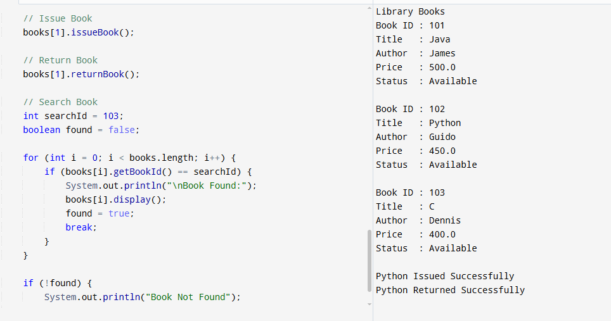

2. Employee Payroll System using Inheritance
Design a payroll system with a base class Employee and derived classes PermanentEmployee and ContractEmployee. Override a method calculateSalary() in each subclass to compute salary differently. Display employee details and salary using runtime polymorphism. Also, construct suitable test cases to validate salary calculation for different employee types. BTL: BL3 (Apply)
Code:
class Employee {
int id;
String name;
Employee(int id, String name) {
this.id = id;
this.name = name;
}
void calculateSalary() {
System.out.println("Salary");
}
void display() {
System.out.println("Employee ID : " + id);
System.out.println("Employee Name : " + name);
}
}
class PermanentEmployee extends Employee {
double basic;
PermanentEmployee(int id, String name, double basic) {
super(id, name);
this.basic = basic;
}
void calculateSalary() {
double salary = basic + (0.20 * basic);
display();
System.out.println("Permanent Employee Salary : " + salary);
System.out.println();
}
}
class ContractEmployee extends Employee {
int hours;
double rate;
ContractEmployee(int id, String name, int hours, double rate) {
super(id, name);
this.hours = hours;
this.rate = rate;
}
void calculateSalary() {
double salary = hours * rate;
display();
System.out.println("Contract Employee Salary : " + salary);
System.out.println();
}
}
public class Main {
public static void main(String[] args) {
Employee e;
e = new PermanentEmployee(101, "Rahul", 30000);
e.calculateSalary();
e = new ContractEmployee(102, "Priya", 25, 500);
e.calculateSalary();
}
}
Output:
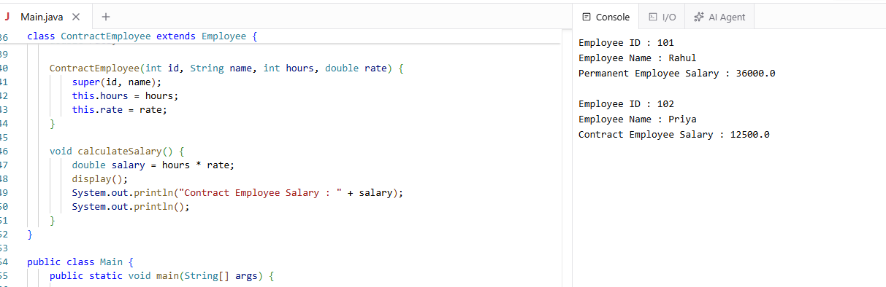

3. Vehicle Rental System using Runtime Polymorphism
Develop a vehicle rental system with a superclass Vehicle and subclasses Car, Bike, and Bus. Override the method calculateRent(int days) in each subclass. Store vehicles in an array of Vehicle references and generate rental bills dynamically. Also, construct suitable test cases to validate rent calculation for different vehicle categories. BTL: BL4 (Analyze)
Code:
class Vehicle {
String name;
Vehicle(String name) {
this.name = name;
}
void calculateRent(int days) {
System.out.println("Rent");
}
}
class Car extends Vehicle {
Car(String name) {
super(name);
}
void calculateRent(int days) {
System.out.println("Car : " + name);
System.out.println("Rent = " + (days * 1000));
System.out.println();
}
}
class Bike extends Vehicle {
Bike(String name) {
super(name);
}
void calculateRent(int days) {
System.out.println("Bike : " + name);
System.out.println("Rent = " + (days * 300));
System.out.println();
}
}
class Bus extends Vehicle {
Bus(String name) {
super(name);
}
void calculateRent(int days) {
System.out.println("Bus : " + name);
System.out.println("Rent = " + (days * 2000));
System.out.println();
}
}
public class Main {
public static void main(String[] args) {
Vehicle[] v = new Vehicle[3];

v[0] = new Car("Swift");
v[1] = new Bike("Honda");
v[2] = new Bus("Volvo");
int days = 3;
for (int i = 0; i < v.length; i++) {
v[i].calculateRent(days);
}
}
}
Output:
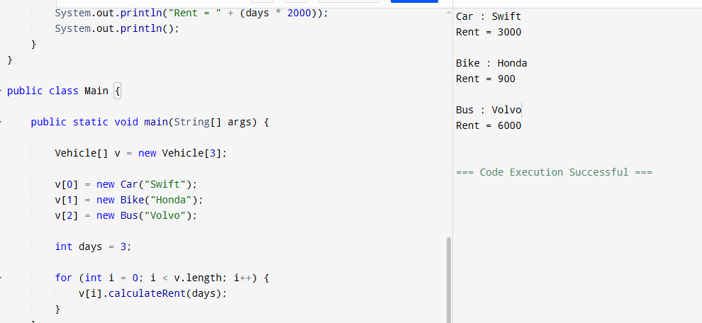

4. Bank Account System using Data Hiding
Design a BankAccount class with private fields accountNumber, holderName, and balance. Implement methods for deposit, withdrawal, and balance inquiry with proper validation. Prevent direct modification of balance from outside the class. Also, construct suitable test cases to validate valid and invalid transactions. BTL: BL3 (Apply)
Code:
class BankAccount {
private int accountNumber;
private String holderName;
private double balance;
// Constructor
BankAccount(int accountNumber, String holderName, double balance) {
this.accountNumber = accountNumber;
this.holderName = holderName;
this.balance = balance;
}
// Deposit
void deposit(double amount) {
if (amount > 0) {
balance = balance + amount;
System.out.println("Amount Deposited : " + amount);
} else {
System.out.println("Invalid Deposit Amount");
}
}
// Withdraw
void withdraw(double amount) {
if (amount <= balance) {
balance = balance - amount;
System.out.println("Amount Withdrawn : " + amount);
} else {
System.out.println("Insufficient Balance");
}
}
// Balance Inquiry
void checkBalance() {
System.out.println("Account Number : " + accountNumber);
System.out.println("Holder Name : " + holderName);
System.out.println("Balance : " + balance);
System.out.println();
}
}
public class Main {
public static void main(String[] args) {
// Direct Input
BankAccount b = new BankAccount(101, "Rahul", 5000);
b.checkBalance();
b.deposit(2000);
b.checkBalance();
b.withdraw(3000);
b.checkBalance();
b.withdraw(10000);
}
}
Output:
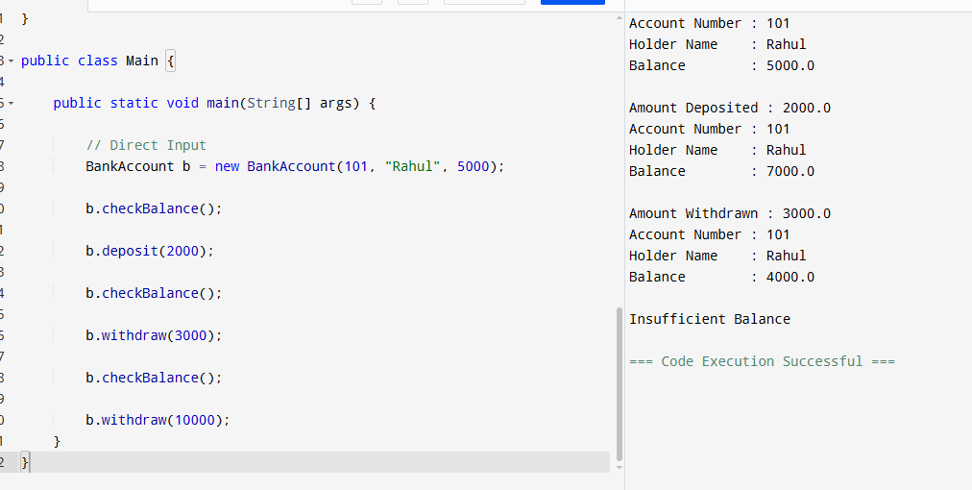

5. University Admission System using Method Overloading
Create an Admission class that overloads the method calculateFee() for:
- Undergraduate students,
- Postgraduate students,
- Scholarship students.
Display the fee structure based on user input and compare the overloaded method executions. Also, construct suitable test cases to validate each overloaded version. BTL: BL3 (Apply)
Code:
class Admission {
// Undergraduate Fee
void calculateFee() {
System.out.println("Undergraduate Fee = 50000");
}
// Postgraduate Fee
void calculateFee(int pg) {
System.out.println("Postgraduate Fee = 70000");
}
// Scholarship Student Fee
void calculateFee(double scholarship) {
double fee = 50000 - scholarship;
System.out.println("Scholarship Student Fee = " + fee);
}
}
public class Main {
public static void main(String[] args) {
Admission a = new Admission();
a.calculateFee(); // Undergraduate
a.calculateFee(1); // Postgraduate
a.calculateFee(20000.0); // Scholarship Student
}
}
Output:
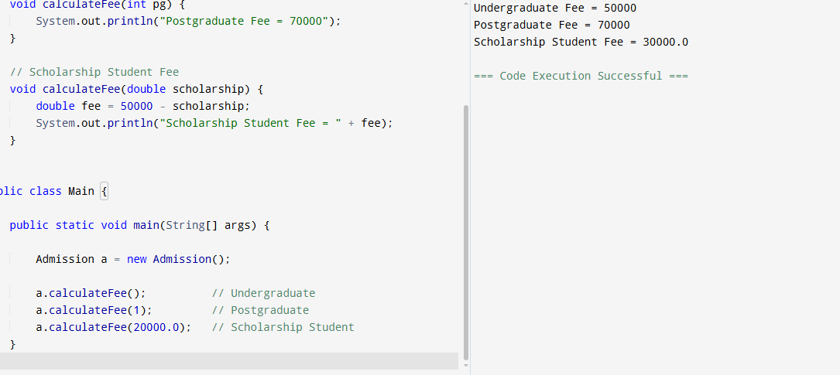

6. Shape Area Calculator using Abstract Class & Polymorphism
Design an abstract class Shape with an abstract method area(). Implement subclasses Circle, Rectangle, and Triangle. Use an array of Shape references to compute and display areas dynamically. Also, construct suitable test cases to validate area calculations and polymorphic behavior. BTL: BL4 (Analyze)
Code:
abstract class Shape {
abstract void area();
}
class Circle extends Shape {
double r;
Circle(double r) {
this.r = r;
}
void area() {
System.out.println("Circle Area = " + (3.14 * r * r));
}
}
class Rectangle extends Shape {
int l, b;
Rectangle(int l, int b) {
this.l = l;
this.b = b;
}
void area() {
System.out.println("Rectangle Area = " + (l * b));
}
}
class Triangle extends Shape {
int base, height;
Triangle(int base, int height) {
this.base = base;
this.height = height;
}
void area() {
System.out.println("Triangle Area = " + (0.5 * base * height));
}
}
public class Main {
public static void main(String[] args) {
Shape[] s = new Shape[3];
s[0] = new Circle(5);
s[1] = new Rectangle(4, 6);
s[2] = new Triangle(8, 5);
for (int i = 0; i < s.length; i++) {
s[i].area();
}
}
}
Output:
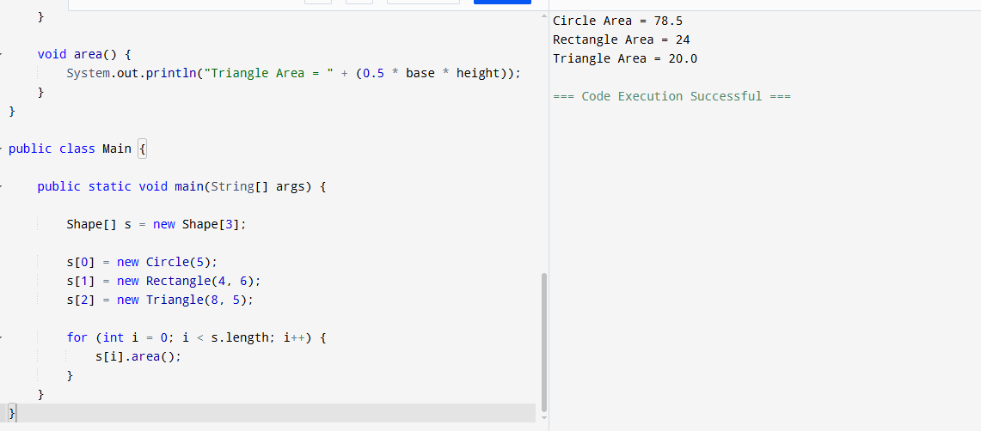

7. Hospital Management System using Interfaces
Develop a hospital management system with an interface MedicalRecord containing methods addRecord() and displayRecord(). Implement the interface in classes Patient and Doctor. Demonstrate interface-based abstraction and object interaction. Also, construct suitable test cases to validate record creation and display. BTL: BL3 (Apply)
Code:
interface MedicalRecord {
void addRecord();
void displayRecord();
}
class Patient implements MedicalRecord {
int id = 101;
String name = "Rahul";
public void addRecord() {
System.out.println("Patient Record Added");
}
public void displayRecord() {
System.out.println("Patient ID : " + id);
System.out.println("Patient Name : " + name);
System.out.println();
}
}
class Doctor implements MedicalRecord {
int id = 201;
String name = "Priya";
public void addRecord() {
System.out.println("Doctor Record Added");
}
public void displayRecord() {
System.out.println("Doctor ID : " + id);
System.out.println("Doctor Name : " + name);
System.out.println();
}
}
public class Main {
public static void main(String[] args) {
MedicalRecord m;

m = new Patient();
m.addRecord();
m.displayRecord();
m = new Doctor();
m.addRecord();
m.displayRecord();
}
}
Output:
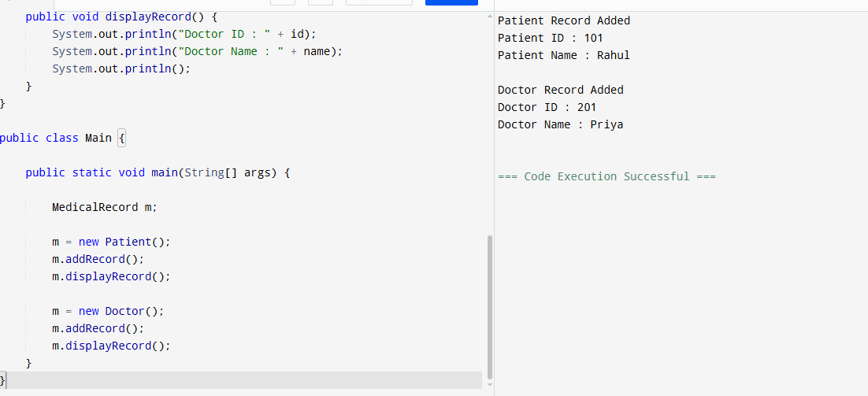

8. Online Shopping Order System using Packages
Create two packages:
- shopping.product
- shopping.order
Implement classes Product and Order in separate packages. Import the packages into a main application that places orders and calculates the total amount. Also, construct suitable test cases to validate package usage, order placement, and bill generation. BTL: BL3 (Apply)
Code:

class Product {

String name;

double price;

Product(String name, double price) {

this.name = name;

this.price = price;

}

}

class Order {

void placeOrder(Product p, int quantity) {

double total = p.price * quantity;

System.out.println("Product Name : " + p.name);

System.out.println("Price : " + p.price);

System.out.println("Quantity : " + quantity);

System.out.println("Total Amount : " + total);

}

}

public class Main {

public static void main(String[] args) {

Product p = new Product("Laptop", 50000);

Order o = new Order();

o.placeOrder(p, 2);

}

}

Output:

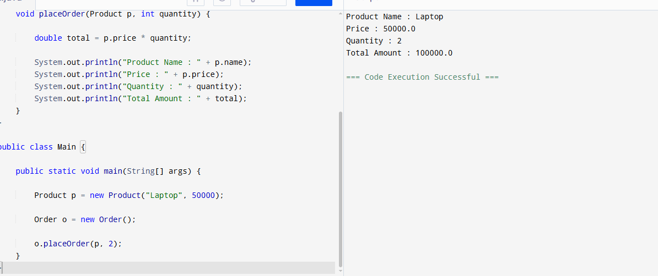

9. Student Result Analyzer using Arrays of Objects
Design a Student class containing roll number, name, and marks in three subjects. Store multiple student objects in an array and implement methods to calculate total, average, grade, and class topper. Also, construct suitable test cases to validate grading and topper identification. BTL: BL3 (Apply)
Code:
class Student {
int rollNo;
String name;
int m1, m2, m3;
Student(int rollNo, String name, int m1, int m2, int m3) {
this.rollNo = rollNo;
this.name = name;
this.m1 = m1;
this.m2 = m2;
this.m3 = m3;
}
int total() {
return m1 + m2 + m3;
}
double average() {
return total() / 3.0;
}
String grade() {
double avg = average();
if (avg >= 90)
return "A";
else if (avg >= 75)
return "B";
else if (avg >= 50)
return "C";
else
return "Fail";
}
void display() {
System.out.println("Roll No : " + rollNo);
System.out.println("Name : " + name);
System.out.println("Total : " + total());
System.out.println("Average : " + average());
System.out.println("Grade : " + grade());
System.out.println();
}
}
public class Main {
public static void main(String[] args) {
Student[] s = new Student[3];
// Direct Input
s[0] = new Student(101, "Rahul", 90, 85, 95);
s[1] = new Student(102, "Priya", 80, 75, 70);
s[2] = new Student(103, "Arun", 95, 98, 96);
int max = s[0].total();
int topper = 0;
for (int i = 0; i < s.length; i++) {
s[i].display();
if (s[i].total() > max) {
max = s[i].total();
topper = i;
}
}
System.out.println("Class Topper");
System.out.println("Name : " + s[topper].name);
System.out.println("Total : " + s[topper].total());
}
}
Output:
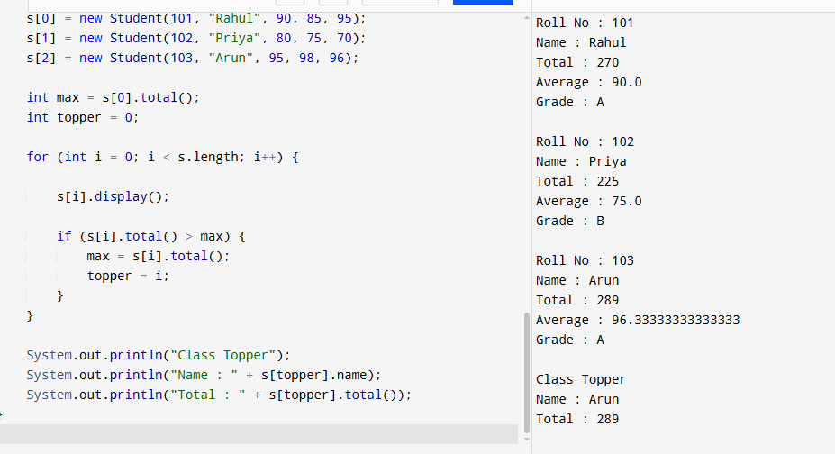

10. Smart Home Device Controller using Hierarchical Inheritance
Develop a smart home system with a base class Device and derived classes Light, Fan, and AirConditioner. Implement methods to turn devices on/off and display power consumption. Use polymorphism to control devices through a common reference. Also, construct suitable test cases to validate device operations and power calculations. BTL: BL4 (Analyze)
Code:
class Device {
String name;
Device(String name) {
this.name = name;
}
void turnOn() {
System.out.println(name + " is ON");
}
void turnOff() {
System.out.println(name + " is OFF");
}
void powerConsumption() {
System.out.println("Power Consumption");
}
}
class Light extends Device {
Light(String name) {
super(name);
}
void powerConsumption() {
System.out.println("Power : 20 Watts");
System.out.println();
}
}
class Fan extends Device {
Fan(String name) {
super(name);
}
void powerConsumption() {
System.out.println("Power : 75 Watts");
System.out.println();
}
}
class AirConditioner extends Device {
AirConditioner(String name) {
super(name);
}
void powerConsumption() {
System.out.println("Power : 1500 Watts");
System.out.println();
}
}
public class Main {
public static void main(String[] args) {
Device d;
d = new Light("Light");
d.turnOn();
d.powerConsumption();
d.turnOff();
System.out.println();
d = new Fan("Fan");
d.turnOn();
d.powerConsumption();
d.turnOff();
System.out.println();
d = new AirConditioner("Air Conditioner");
d.turnOn();
d.powerConsumption();
d.turnOff();
}
}
Output:
